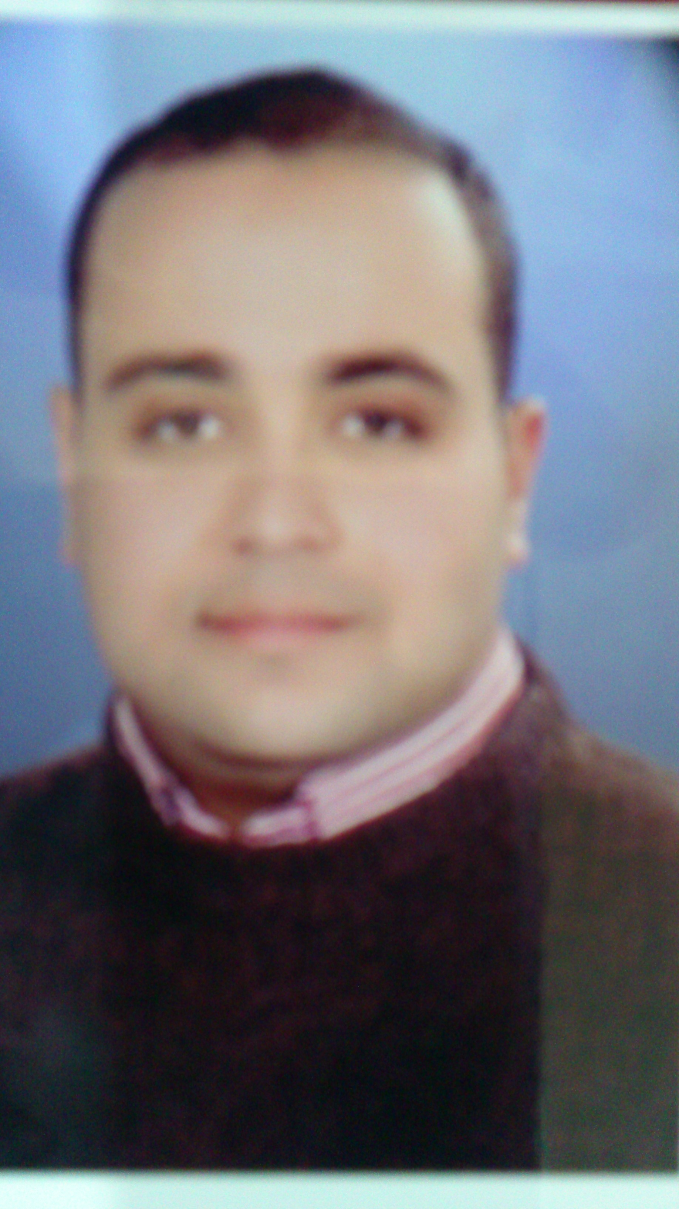

OSAMA ALI HUSSIEN ALIZARZOUR

email – dr_osamazarzour@yahoo.com

Assuit, Egypt.

phone (0020-10) 93997199

personal profile

Experienced, professional, self-directed, analytical, and organized. Excellent communication skills, self-motivated, hardworking both as an individual and team member. Enjoy the challenge of change and self-improvement.
I am determined to contribute positively to the overall Medical care plan for better outcome.

essentials

Nationality Egyptian
Date of Birth 15 september 1985
Sex Male
Civil Status Married
Languages known English, Arabic
Permanent Address Al-Sedfawy Street, Al Zahraa District, Assuit, Egypt

professional qualification

2001– 2008 Bachelor of Medicine
December 2013 Master Degree of Radiodiagnosis (Good)

- Bachelor of Medicine (EXCELLENT WITH GRADE OF HONOR )….2008
Assuit University. ( EGYPT)

- Master Degree Of Diagnostic Radiology (Good) ….. 2013
Radio-Diagnosis Department- Assuit University Hospital (AUH)- University of Assuit. ( EGYPT)

CURRENT OCCUPATION:

Assistant lecturer-Radiodiagnosis department-Assiut university

professional experience

March 1st 2009 - till 28 feb. 2010

- Assuit University Hospital (AUH)- University of Assuit. ( EGYPT)
- House Officer

March 1st 2010 – till 28 feb. 2013

- Radio-Diagnosis Department- Assuit University Hospital (AUH)- University of Assuit. ( EGYPT)

- Resident Doctor

March 1st 2013-December 2013
- Radio-Diagnosis Department- South Egypt cancer Institute (SECI)- University of Assuit. ( EGYPT)

- DEMONSTRATOR.

December 2013 – Till Now
Assistant lecturer-Radiodiagnosis department-Assiut university

- Specialist of Radiology

Duties (July, 2009 – up to date):

  - Supervising and directing residents and fellows at our department
  - Regularly participating in the departmental educational meetings, audit meetings, and regional scientific meetings. I also actively share in preparing and presenting lectures for the weekly scientific meetings and annual basic and clinical science courses in the department.
  - Helping in the research programs held at our department.
  - 6 hours in our department imaging untis responsible for reporting a diagnosis for cases. Four days weekly .

computer skills
_____________________________________________________________________________________________

- Operating of MS Power Point, MS Word, MS Excel, MS Outlook.
- • ICDL: (International Computer Driving License).

